**MACHINE LEARNING ARTICLE FOR BEGINNERS**

**Presented By**

Kainat bibi

**Introduction to Machine Learning: A beginner's guide to understanding machine learning and its practical applications**

In the world of technology, machine learning (ML) is a smart way that computers learn and improve for handle information and make decisions on their own, without needing step-by-step instructions. This tech wizardry is making our computers smarter and more capable to learn from experience in ways we couldn't have imagined before. This article serves as a comprehensive guide for beginners, breaking down the fundamentals of machine learning and exploring its practical applications.

**Introduction to Machine Learning**

Before going in depth of machine learning, first we should to know what is machine learning? So, to understand the concept of machine learning look at the given diagram:

As in diagram, it is clearly shown that machine learning is a subset of artificial intelligence. In simple words, an artificial intelligence is the study to create digital brain. In computer science, AI empowers development of methods that allow computers to learn without explicit programming unlike traditional programming where rules are defined explicitly.

As machine learning is the branch or subset of AI focuses on methods that can learn from experience and examples, also make predictions on new data rather than relying on the hard-coded rules.

**Key Concepts in Machine Learning**

**Data:** Data serves as the backbone of machine learning. It comes in various forms - text, numbers, images, or videos. The quality and quantity of data significantly influence the success of a machine learning model.

**Algorithm:** An algorithm, essentially a set of instructions that guides the machine learning model in its learning process. The choice of algorithm depends on the nature of the problem at hand.

**Training:** During the training phase, the model learns patterns and relationships within the data. It iteratively adjusts its parameters to minimize the difference between its predictions and actual outcomes, a process crucial for model refinement. For example,   
training a machine learning model is like teaching a computer to recognize cats and dogs in pictures. Initially guessing, the model adjusts its thinking by learning from mistakes. During the process, it fine-tunes its understanding by repeatedly correcting errors. The goal is for the computer to get so good that it accurately identifies cats and dogs in new pictures it has never seen before. It's a bit like teaching the computer to learn and make decisions, much like we do from experience

**Testing and Evaluation:** After training, the model is tested on unfamiliar data to assess its ability to apply what it learned to new situations, known as generalization. Evaluation metrics like accuracy, precision, and recall provide insights into how well the model performs without referencing specific examples. These metrics help gauge the overall correctness, accuracy in identified instances, and the model's ability to capture all relevant instances, respectively.

**Features and Labels:** In machine learning, features are input variables, providing details for the model to analyze. Labels are desired outcomes or predictions based on these features. The interaction between features and labels is fundamental for the model's learning process, as it identifies patterns and relationships to make accurate predictions without specific examples.

**Types of Machine Learning**

* **Supervised Learning:** The model is trained on a labeled dataset, where the input data is paired with corresponding output labels. It learns to map the input data to the correct output during training. For Example, giving a bunch of pictures to computer, each one labeled with the name of that pictures shows what's in it—like cats or dogs. The computer learns from these examples, after learning its better to figuring out in new pictures that what's in a picture.

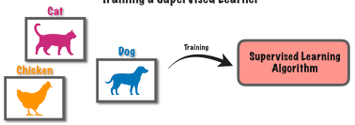

* **Unsupervised Learning:** The model is trained on unlabeled data, and it learns to find patterns or structures within the data without explicit guidance on the output. For example, giving the computer a bunch of photos without any labels or name. The computer figures out on its own, without telling them about data labels, it knows how to group similar photos together. It discovers patterns without being explicitly guided.

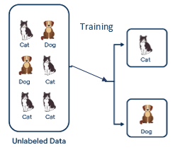

* **Reinforcement Learning:** The model learns by interacting with an environment and receiving feedback in the form of rewards or penalties (observation). It aims to maximize cumulative reward over time by receiving observation. For example, training a computer to play a game, if it plays with good moves, it gets rewards; if it messes up, there are consequences. The computer learns from this feedback, gradually becoming skilled at the game through trial and error.

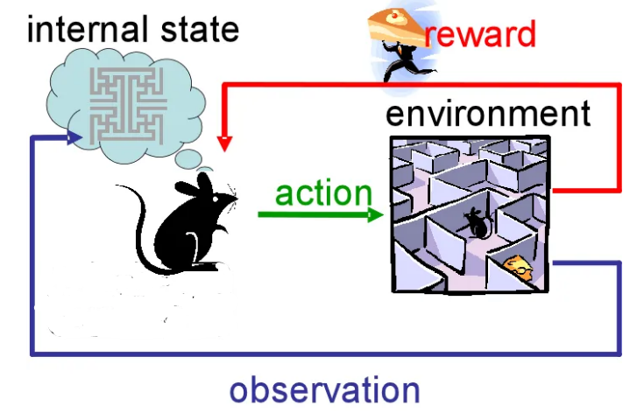

**Common Machine Learning Algorithms**

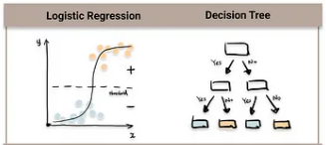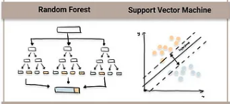

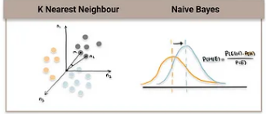

**Linear Regression** predicts outcomes like prices or scores based on features like size or time. Think of it as drawing a straight line through points on a graph. **Decision Trees** make decisions by asking yes-or-no questions about features, like a flowchart for choices. **Random Forest** combines many decision trees to make more accurate predictions, like a group of friends giving advice. **Support Vector Machines** draw lines to separate things into groups, like sorting red and blue balls. **K-Nearest Neighbors** categorizes things based on what's closest, like asking neighbors for advice.

**Practical Applications of Machine Learning**

**Image Recognition:** ML enables computers to recognize and interpret images, making applications like facial recognition, object detection, medical imaging, barcode scanning, gesture recognition, satellite image analysis, artwork identification, visual search, and quality control in manufacturing.Top of Form

**Speech Recognition:** Speech recognition systems, like virtual assistants, use ML to understand and respond to human speech like voice assistants (e.g., siri, alexa), transcription services, interactive voice response (IVR) systems, speech-to-text applications, and voice commands in automotive systems.

**Recommendation Systems:** ML algorithms analyze user preferences and behavior to recommend products, movies, or content, enhancing user experience like movie and TV show recommendations (Netflix), product recommendations (amazon), music suggestions (Spotify), book recommendations (Goodreads), content recommendations (YouTube).

**Predictive Analytics:** Businesses leverage ML for predicting future trends, sales, and customer behavior, aiding in decision-making processes like sales forecasting, customer churn prediction, stock price prediction, equipment maintenance predictions, and demand planning in supply chain.

**Healthcare:** ML assists in diagnosing diseases, predicting patient outcomes, and personalizing treatment plans based on individual health data.

**Autonomous Vehicles:** ML plays a crucial role in enabling self-driving cars to perceive their surroundings, make decisions, and navigate safely.

**Conclusion**

Machine learning is a powerful tool with diverse applications, transforming industries and shaping our daily lives. As you embark on your journey into the world of machine learning, remember that continuous learning and hands-on experience are key to mastering this exciting field. The power of machine learning lies not only in its ability to make accurate predictions but in its potential to drive innovation, improve decision-making processes, and unlock solutions to complex challenges. Explore different algorithms, experiment with real-world datasets, and stay curious about the ever-evolving landscape of machine learning.

**_____________________________________**